Programming Principles 02 Tutorials 03

Task 1 – Enhancing a Conversion Program

Open one of your simple conversion programs from Tutorial 2 in the IDE.

Modify it so that the program first prompts the user to choose whether they wish to convert from Metric to Imperial or from Imperial to Metric, e.g. kilometres to miles or miles to kilometres. Based on the user’s response, prompt them for a value and perform the appropriate conversion as normal.

Here is pseudocode of the program design:

Print options '1 | for | Metric to Imperial | Pseudocode
2 | for | Imperial to Metric'

Prompt user for choice

If choice == 1

Prompt user for value in Metric

Convert value to Imperial

Print result

Else if choice == 2

Prompt user for value in Imperial

Convert value to Metric

Print result

Else

Print 'invalid choice' error message

Refer to Tutorial 2 for the calculations needed to convert Metric/Imperial units.

Note that the “Prompt, Convert, Print” steps within this program design are essentially your original conversion program from Tutorial 2.

For practise, try to draw a flowchart of this program design.

Task 2 – Enhancing the Grade Calculation Example discussed in the lecture

Create a new file in the IDE and copy the grade calculation code from the Lecture 2 into it. Save the file and test the program to ensure that it works.

Now try to modify the program to incorporate the following criteria:

- After the prompt to enter a mark, a second prompt should ask the user whether or not they passed the exam, e.g. “Did you pass the exam? (y/n): ”

- Assume that passing the exam is required in order to pass the unit. Hence, if the mark is greater than or equal to 50 but “n” was entered at the second prompt, the final grade should be “FI (Fail/Incomplete)”
  - Otherwise, the code to calculate the grade works as per the example

You should only need to add a few new lines of code to the example to implement the new criteria.

It’s very easy to make your code accommodate for users typing “N” instead of “n” to the second prompt by using the toLowerCase() method on the string containing their response to the prompt. It is up to you whether you convert their response to lower case when you obtain it, or just when you are comparing it to “n” in the boolean expression of an if-then statement.

Task 3 – Income Tax Program

The following table from the US Tax Office website describes the formula applied to calculate the amount of income tax that must be paid.
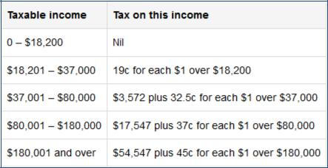

Based on this table, write a program that prompts the user to enter their income and then shows the amount of tax that they must pay. Before writing any code, use either (or both) pseudocode or a flowchart to design the program.

That’s all for this workshop. If you haven’t completed the workshop or readings,

find time to do so before next week’s class.

